CITATION STYLE REGULATIONS
AND BIBLIOGRAPHY
AT NHA TRANG UNIVERSITY
(Issued together with Decision No.1263 /QĐ-ĐHNT dated September 2019 of the Rector of Nha Trang University)

1. Why cite references and cite sources?
When presenting academic products such as essays, topics, projects, dissertation courses, dissertations, dissertations, scientific articles, final reports on scientific research topics, presentations of scientific research seminars ... (collectively referred to as scholarly products in written form), authors often use theoretical basis, ideas, figures, research findings,... (collectively referred to as information) of previously published works in the form of scientific articles, theses, dissertations, books, textbooks, information on websites ... However, the author must acknowledge that such information is that of other authors and not his own by crediting the source that cites such information. This practice follows ethical standards and academic integrity, shows respect and recognition for the intellectual work of others, and avoids being attributed to plagiarism.
Citations also show that the author has extensive research on relevant works because through citations, the author inherits existing scientific knowledge, compares, illustrates, comments, criticizes,... thereby finding knowledge gaps that need to be researched, solving new problems and demonstrating that their research works are new, contributing to the common knowledge base; Show the reader that the author's article is reliable, that the information given by the author is clearly sourced, based on solid arguments of previous studies and publications.

2. Forms of quotation
When writing scholarly products (or otherwise called articles), authors often use (represent) sentences, speeches, ideas, theories, figures, images, diagrams, research results, statements, publications ... in articles by other authors for reasons as presented in section 1.
There are two forms of citation that are direct and indirect quotation:
-Direct quoting or also known as quoting: is the verbatim use of a sentence, a paragraph, diagram, process ... from some reference to the article. When quoting verbatim, the text of the quote must be enclosed in a pair of quotation marks. In this case, it is mandatory to write the page number of the cited source so that readers can easily search and check when needed.
For example: "Vietnamese people from North to South, all follow the same custom, speak the same language and keep the same memory, it is the homogeneity of a people from the beginning of the country to the end of the country." (Tran Trong Kim, 2008, p. 17).
In case it is not possible to write other than or want to keep the text of the cited author verbatim for comparison, contrast or commentary, use the direct quote style.
- Indirect quotation , also known as paraphrase: is the use of another sentence to express information from the reference source without changing the content or expressing the content of the quote in a more concise sentence. This is the type of incentive citation used. This type of citation is not required to page number the source of the citation, but if there is a page number, it will make it easy for readers to collate or refer to when needed.
Example 1: To learn a new programming language, the only way is to use that language to write programs (Kernighan and Ritchie, 1978)
Example 2: According to Tran Trong Kim (2008), Vietnamese people are homogeneous in language and customs.
Thus, whether using direct or indirect quotation, the writer must credit the source quoted next to the citation so that each document can be clearly identified.

3. Regulations on quotation and attribution of Nha Trang University
In practice, there exist many types/ways of quoting and attributing sources depending on different journals, publishers or schools/institutes. Although the formats of citation and citation styles vary, there are generally two main types: (1) by author's full name plus year of publication and (2) by number. Each type has its own characteristics (which can be called advantages and disadvantages) so they exist in parallel and are used according to the habits or conceptions of different academic fields. In order to unify the way of quoting but still ensure universality and science, Nha Trang University stipulates the application of one of the two types of quotation mentioned above depending on the academic field. Authors are only allowed to choose one type of citation in an academic work. Details on the two citation attributions are detailed below:

3.1 Rules for attribution by first name/first name and year of publication
This type is often referred to as annotated or Harvard, but to be more precise, Harvard citation is one of the citations by first name/year of publication. For the sake of brevity, the citation style and attribution by first name/first name and year of publication is called Harvard style. This citation style highlights the name of the author of the work/document cited and shows the year of publication for old or new cited information, easily helping the writer and reader organize the cited information in chronological order.
When citing Harvard-style sources, there are usually two forms:
- Content quoted (Author, year published, page number): when emphasizing content. Examples: Studies on customer satisfaction with public administration services (Ngo Thanh Hung, 2010; Ly Thi Thuy Huong, 2011) shows that there are 4 factors influencing...
- Author (year of publication, number of pages) content cited: when emphasis is made on the author being cited. Page numbers are often required when citing only a specific piece of information in the cited document. For example: According to Hoang Trong and Chu Nguyen Mong Ngoc (2008, p. 76) the appropriate number of samples is....
The following are specific and detailed rules of presentation for Harvard-style citation attribution:
For Vietnamese authors, quote (record) full name and surname.
For authors who are foreigners writing in English, criticize the author's surname.
If the authors are agencies or organizations, write the name of that agency/organization. If the names of such agencies or organizations have common abbreviations and are well known, they may be abbreviated, if not written in full.
Examples of Harvard-style citation attribution:
How to cite attribution | Examples
The case of two authors
Write down the names of the two authors, joined by letters and (or the letter and for English) to connect the two authors. | - East and West (1972) developed a valuable technique...  - A valuable technique is developed... (East and West, 1972).
The case of more than two authors
Include only the name of the first author and the phrase associate, (or the letter et al. if written in English). | - Nguyen Van Thanh et al. (2005) pointed out that.....  Many management tools and methods have been theorized (Have et al., 2003).  - Mutations in both FatM and RAM2 impair arbuscule branching (Wang et al., 2012; Bravo et al., 2017).
The author has more than 1 material published in 1 year
If such documents are cited in the article, add the letters a, b, c after the year. | - According to World Bank data (2005a, 2005b) per capita income...  - In recent studies by Smith (2000a, 2000b, 2000c), the issue regarding to…
A quote from various sources
Include the author's name, year of publication of the first source, semicolon; Next is the other author's name, year of publication. All are enclosed in parentheses. Ranked in order of year of publication, first published, first recorded. | Studies on customer satisfaction with public administration services (Nguyen Van Long, 2009; Ngo Thanh Hung, 2010; Ly Thi Thuy Huong, 2011) shows that there are 4 factors...
Cite a piece of information via a document that is not the original (secondary citation),
Include the original author name of the material being extracted and include the word "quoted in" and a secondary source. It is recommended to quote from the original document and minimize secondary citations. | Data from the General Statistics Office (2007) quoted in Nguyen Van Hoang Thanh (2009) show that...  Ellis (1990) cited by Cox (1991) suggests that...
Where documents cited are laws or standards issued by state agencies or organizations.
For standards:  Do not cite the name of the drafting agency (e.g. Ministry of Agriculture and Rural Development), but only the number of the standard, which contains the year of issuance.  For laws, decrees, circulars...:  Do not cite the drafting and issuing agency (e.g. the National Assembly, the Government, etc.), but instead use the name of the law, decree or circular, followed by the year of issuance. | Citing the standards:  - The sample before testing shall be left in a free state under standard environmental conditions for not less than 24 hours (TCVN 8393: 2012).  - Theo (ASTM D3244 – 07), to process test results to determine conformity to technical requirements....  Quoting the text of the law and under the law:  - Aquatic resources are resources owned by the whole people and uniformly managed by the State (Law on Fisheries, 2003).  - Support investment in the development of handicraft secondary schools in provinces with many traditional craft villages (QĐ No. 1956/QD-TTg, 2009).

3.2. Attribution by numbering
With this type of citation attribution, the cited source is numbered. Typical for these types of citation attribution are Vancouver and IEEE styles. In fact, in the world, there are many forms of numbered citation attribution, called Numbered in this guide. Typically, the citation is typed in the order in which it appears in the article and enclosed in curly brackets, square brackets, or superscripts. However, Nha Trang University uniformly stipulates that citation sources are placed in square brackets for the convenience of searching and searching for readers.
The provisions in specific cases of citation attribution by numbering are illustrated below:
How to cite attribution | Examples
The case for quoting from a source
It is usually necessary to state the name of the author, write the content of the quote, write the source quoted with numbers enclosed in square brackets, if the verbatim citation requires additional page numbers. To show topicality (time of publication), after the name of the author must be the year of publication enclosed in parentheses. If the previous year of the author's name is stated, there is no need to add the year of publication in parentheses.  If the source has two authors: use the word "and" to join the two authors.  If the source has more than two authors: include the first author's name and add the word "et al.") | - According to Paul R. Niven (2006), KPIs are central to the BSC balanced scorecard [69, p. 30].  The work "Subjectivity and the Weighting of Performance Measures: Evidence from a Balanced Scorecard" published by Larcker and Meyer (2003)[46] showed that....  - In 1937, Lunde et al. first published on the structure of fucoidan from the algae L. digitata with the formula... [15].  - According to Johanson et al. (2006) [47], through the method of summarizing practical experience in......
Cases cited from multiple sources
This case often emphasizes content, so it may not list the names of the authors of the sources. The cited documents are numbered so that the small number comes first, the large follows separated by commas; The continuous series of numbers is marked with the beginning, last number and hyphen. | - Studies on customer satisfaction with public administration services [2, 5, 12-13] show that there are 4 factors influencing...  There have been attempts to replace immunization test mice with invitro assays, such as enzymes binding immunoassays [57,60] or polymerase chain reactions [20-22], but they are still experimental.
Cite a piece of information through a document other than the original document (secondary citation)
Include the original author name of the material being extracted and include the word "quoted in" and a secondary source. It is recommended to quote from the original document and minimize secondary citations. | - General Statistics Office figures [37] quoted in documents [47] show...  - Ellis [35] cited by Cox [40] suggests that...

4. Document Citation Process
When making citations and attributing citations, the following steps should be taken:
Step 1: Prepare accurate and complete information about the cited source including:
- Reference sources are books: author, editor, compiler, year of publication, title, volume number, edition, publisher, place of publication.
- Reference sources are journals: article authors; year of publication, article name, journal name, magazine issue and volume, pages of the article.
- Reference sources are newspapers, popular magazines (magazine, newspaper): the author of the article, the year of publication, the name of the article, the name of the magazine, the issue, the volume of the magazine, the page of the article.
- Reference sources from the Internet or other electronic documents: in addition to such information, it is necessary to record the time of accessing the document on the Internet, the name of the database or the web address (URL: uniform resource locator) of the document.
Step 2: Write the content of the quote and insert the cited source in the appropriate place in the article according to the selected rule.
After identifying the source, the author needs to perform the following tasks:
- Read references to find important ideas;
- Summarize and/or paraphrase information or accurately transcribe the passage intended to be quoted;
- Record the source, e.g. author, date of publication, title, place of publication, publisher;
- Put citation-oriented references on a curated list with MS. Word's citation assistant or other professional citation support software. If you do not use assistive tools, you must perform reference management manually.
- Insert the cited source in the appropriate place in the article according to the selected rule.
Step 3: Catalog the cited material at the end of the article.
Usually, at the end of articles one lists bibliography or bibliography of citations.
- List of references or citations: includes documents that have been cited in the article.
- Bibliography: includes cited and uncited documents that are referenced by the author to form ideas during compilation or related documents that are oriented to the reader.
For highly academic products such as master theses, doctoral topics, overview essays, doctoral theses, scientific articles, reports on scientific research results, scientific presentation reports, it is mandatory to use the List of cited documents. All materials cited in the article must be listed in the cite bibliography and vice versa, all materials in the cite bibliography must be cited in the article. For other scholarly products, references listed but not cited in the article should be minimized.
The list of documents cited is specifically guided in section 5.

5. Guidelines for bibliography / bibliography

5.1 General rules
Whether the author chooses the Harvard citation style or the Number type, Nha Trang University stipulates only one form of listing documents according to the rules guided below:
- Citations/references should be bibliographed at the end of the article, with continuous numbering.
- References in Vietnamese, references in foreign languages (English, French, Russian...), and references are information or articles on websites grouped separately (see Appendix 1).
  - The Vietnamese TLTK group is ranked first,
  - Next is the foreign-language TLTK group,
  - Finally, the TLTK group is the websites (if any). (Note: TLTKs are articles on websites with unknown authors or publishers and/or whose content is not peer-reviewed are not recommended for citation in highly scholarly products such as scientific articles, dissertations or dissertations).
- In each TLTK group, the order is placed in the author's surname, if the author's surname coincides, it is ranked by name.
- The author is Vietnamese: write the name in the order of Vietnamese; the author is foreign: write the surname first, then the abbreviation in the English spelling; Author is an agency/organization: write the name of the organization fully and can include an acronym or use an abbreviation when it is common.
- The names of the authors in an article need to list in full; with cited material with two or more authors: before the final author, add the word "and" for Vietnamese and the word "and" for English.
- Do not record the academic ranks or degrees of the authors.
- When the cited material is a book, it is necessary to indicate the page number of citations (because it is rare to cite the whole book).
- The reference attribution rule must be consistently implemented throughout the bibliography.
- When the number of documents cited is greater than 15, authors are forced to use Microsoft Word's citation assistant or other professional citation and bibliography software to ensure accuracy and consistency.
For an example of the general format of the citation/reference bibliography, see Appendix 1.
Nha Trang University has created two citation styles according to the University's regulations applied to the EndNote citation support tool. Students, doctoral students, lecturers and researchers can download from Nha Trang University's data archive website at: http://tailieu.ntu.edu.vn
Citation style | EndNote citations
Harvard | File Harvard-NTU.ens
Numbered | File Numbered-NTU.ens
Note: Log in with staff number or student code as (same account that password with training management system, student management or E-Learning system of HUST).
Instructions for using citation styles with pre-made EndNote citation support software are presented in Appendix 2.

5.2 Specific format of each type of document cited in the list of cited documents
Document type | General form | Example
Published books, textbooks, reference materials | Include the following key information:  Name of author/editor/translator or responsible organization (Year of publication), Book title – italics, Volume or proper name of each volume if applicable, Reprint if not for the first time, Publisher, Place of publication, Page number if applicable.  Vietnamese author: full name; Alien author: write your first and last name. If the author is an organization: state the organization. | Tran Duc Ba and Nguyen Van Tai (2004), Aquatic Refrigeration Technology, Vietnam National University Press, Ho Chi Minh City.  Cengel, Y.A. and Boles, M.A. (1994), Thermodynamics: an engineering approach, 2nd Edition, McGraw Hill, London.
Book chapter, book section, Edited book | Author (year), the name of the chapter (chapter of the book) is written normally, followed by Print: Full name of the author (Ed.), name of the book in italics, Publisher, Place of publication, page number. | Bernstein, D. (1995), Transportation planning, In: Chen W.F. (Ed.), The civil engineering handbook, CRC Press, Boca Raton, pp. 101-125.
Dissertations, dissertations, | Includes the main information:  Author (Year of publication), Title of thesis or thesis – italics, Name of degree, Name of institution granting degree, [Location of institution.]  Note: The field information in the pair of square brackets is optional (may or may not be). | Exelby, H.R.A. (1997), Aspects of gold and mineral liberation, PhD thesis, University of Queensland, Brisbane.  Ngo Thi Hoai Duong (2014), Optimizing chitin-chitosan production process from white shrimp scrap to improve product efficiency and quality, PhD thesis, Nha Trang University.
Scientific research topic report | Include information: Author (year of publication), name of topic in italics, type of report, topic number, place of execution. | Nguyen Ngoc Duy (2011), Study on anti-disease effects of vascular chitosan by irradiation method on tilapia, Final report of scientific and technological research at grassroots level, Code: CS/11/07-02, Ho Chi Minh City.
Articles published in scientific journals | Includes the main information:  Name of the author of the article (Year of issue), "Title of the article", Full name of the journal – italics, volume or volume, (number or issue), page (p.) or pp. page number. | Nguyen Quoc Hien, Le Hai, Le Quang Luan, Truong Thi Hanh, Pham Thi Le Ha (2000), "Research on making oligochitosan by radiation technique", Journal of Chemistry, Vol. 2(38), pp. 22-24.  Huffman, L.M. (1996), "Processing whey protein for use as a food Ingredient", Food Technology, 50 (2), pp. 49-52.
Conference reports printed as proceedings | Name of the authors of the article (Year of publication), "Title of the article", Name of the workshop, Place of the workshop, Publisher if applicable, volume if applicable, p. or pp. page number. | Bourassa, S. (1999), "Effects of child care on young children", Proceedings of the third annual meeting of the International Society for Child Psychology, International Society for Child Psychology, Atlanta, Georgia, pp. 44-46.  Nguyen Anh Dung, Nguyen Dinh Huyen and Tran Tich Canh (1999), "Research on manufacturing chitosan-g-co-HEMA materials by radiation technique", Proceedings of the 3rd National Conference on Nuclear Physics and Technology, Da Lat, Publishing House. Science and Engineering, pp. 647-651.
Standard | Name of the body/organization issuing the standard (Year of issuance), Title of the standard, Standard number including identification of the national or individual standard, Publisher of the standard, Place of publication. | International Organization for Standardization (1982), Steels - Classification - Part 1: Classification of steels into unalloyed and alloy steels based on chemical composition, ISO 4948-1:1982, International Organization for Standardization, Geneva.  Ministry of Agriculture and Rural Development (2012), National Standard (TCVN 8393:2012) Fishing net materials - Yarn, Wire and Sheet Nets - Technical requirements and test methods.
Laws, decrees, circulars, regulations... | Name of state or government agency, (Year of signing of the promulgation), Name of the document, | National Assembly of the Socialist Republic of Vietnam (2003), Law on Fisheries - Law No. 17/2003/QH11.  The Government (2009), Decision No. 1956/QD-TTg dated 27/11/2009 of the Prime Minister approving the Project on Vocational Training for Rural Workers until 2020.
Patent | Name of authors (year of publication), Name of invention, Date of issue, Title of invention, Patent number - including country. | Cookson, A.H. (1985), Particle trap for compressed gas insulated transmission systems, US Patent 4554399.
E-magazine | For electronic science journals, the paper has a Digital Object Identifier, citing the same as a print journal, but adding information about the paper's DOI. | Morse S.S. (1999), "Factors in the emergence of infectious disease", Emerging infectious diseases Journal,1(1), DOI: 10.3201/eid0101.950102
 | With other e-magazines:  Write down basic information such as the name of the writer or publisher (year), article name, access address, and access date.  Note: use the Electronic Article style in EndNote to enter information. | Nguyen Duy Quynh (2019), Principles of organizing state power in Ho Chi Minh thought: Content and values, accessed at http://www.tapchicongsan.org. vn/ Home/Nghiencuu-Traodoi/2019/54042/Nguyen-tac-to-chuc-quyen-luc-nha-nuoc-trong-tu-tuong-Ho.aspx, accessed on 30/5/2019
Articles or information on websites | Access address of the site, (name of the site, time of posting, name of the article), access time. Note: this type of reference is placed at the bottom of the TLTK category. | https://tuoitre.vn/truong-dai-hoc-rao-riet-chong-dao-van-20171013085442991.htm (Tuoitre Online, 2017, The University Aggressively Fights Plagiarism), retrieved 2019-05-03.

APPENDIX 1 Examples illustrating bibliography/citations
BIBLIOGRAPHY
Vietnamese
- Ministry of Agriculture and Rural Development (2012), National Standard (TCVN 8393:2012) Fishing net materials - Yarn, Wire and Sheet Nets - Technical requirements and test methods.
- Bui Duy Du, Dang Van Phu, Bui Duy Cam and Nguyen Quoc Hien (2008), "Study on the water-soluble chitosan circuit shear effect by Gamma Co-60 radiation", Journal of Chemistry, 1(46), pp. 57-61.
- Ngo Thi Hoai Duong (2014), Optimizing chitin-chitosan production process from white shrimp scrap to improve product efficiency and quality, PhD thesis, Nha Trang University.
- Nguyen Anh Dung (2009), Polysaccharides - bioactivity and applications, Vietnam Education Publishing House, pp.100-101.
- Nguyen Anh Dung, Nguyen Dinh Huyen and Tran Tich Canh (1999), "Research on manufacturing chitosan-g-co-HEMA materials by radiation technique", Proceedings of the 3rd National Conference on Nuclear Physics and Engineering in Da Lat, Publishing House. Science and Engineering, pp. 647-651.
- Nguyen Duy Quynh (2019),"Principles of organizing state power in Ho Chi Minh thought: Content and values", Communist Magazine, accessed at http://www.tapchicongsan.org.vn/Home/Nghiencuu-Traodoi/2019/54042/Nguyen-tac-to-chuc-quyen-luc-nha-nuoc-trong-tu-tuong-Ho.aspx, accessed on 30/5/2019.
- Nguyen Ngoc Duy (2011), Study on anti-disease effects of vascular chitosan by irradiation method on tilapia, Final report of scientific and technological research at grassroots level, Code: CS/11/07-02, Ho Chi Minh City.
- Nguyen Quoc Hien, Le Hai, Le Quang Luan, Truong Thi Hanh, Pham Thi Le Ha (2000), "Research on making oligochitosan by radiation technique", Journal of Chemistry, Vol. 2(38), pp. 22-24.
- National Assembly of the Socialist Republic of Vietnam (2003), Law on Fisheries - Law No. 17/2003/QH11.
- Tran Duc Ba and Nguyen Van Tai (2004), Aquatic Refrigeration Technology, Vietnam National University Press, Ho Chi Minh City.
- Institute of Statistical Sciences (2005), Some Statistical Methodological Issues, Statistics Publishing House.

English
- Andrew J. M. (2001), "Determination of minimum inhibitory concentrations", Journal of antimicrobial chemotherapy, 48, pp. 5-16.
- Bautista J., Jover M., and Gutierrez J. F. (2001), "Preparation of crawfish chitin by in situ lactic acid production", Process Biochemistry, 37, pp. 229-234.
- Bernstein D. (1995), Transportation planning, in: The civil engineering handbook, Chen W.F., Editor, CRC Press, Boca Raton.
- Chen J. and Yang L. (2012), "Study On Application Of Monitoring The Melt Flow Balance Of Injection Molding Process By Using Cavity Pressure Monitoring Technology", Proceedings of the 2nd International Conference on Computer and Information Application (ICCIA 2012).
- Cookson A.H. (1985), Particle trap for compressed gas insulated transmission systems, US Patent 4554399.
- Exelby H.R.A. (1997), Aspects of gold and mineral liberation, PhD thesis, University of Queensland, Brisbane.
- Holman J.P. (2002), Heat transfer, 9th Edition, McGraw-Book Company, pp. 100-102.
- International Organization for Standardization (1982), Steels - Classification - Part 1: Classification of steels into unalloyed and alloy steels based on chemical composition, ISO 4948-1:1982, International Organization for Standardization, Geneva. pp. 101-120.
- Morse S.S. (1999),"Factors in the emergence of infectious disease", Emerging infectious diseases Journal, 1, DOI: 10.3201/eid0101.950102.
- Rännar L.E. (2008), On optimization of injection molding cooling, Thesis for doctoral degree, Norwegian University of Science and Technology.
- Rao N.S. and Schumacher G. (2004), Design formulas for plastics engineers, 2nd Edition, Hanser Verlag Munich, pp. 145-148.
- Saifullah A.B.M., Masood S.H., Nikzad M. and Brandt M. (2016), An Investigation on Fabrication of Conformal Cooling Channel with Direct Metal Deposition for Injection Moulding, in: Reference Module in Materials Science and Materials Engineering, Elsevier.
Websites
- http://www.rcuk.ac.uk/RCUK-prod/assets/documents/reviews/grc/RCUKPolicyandGuidelinesonGovernanceofGoodResearchPracticeFebruary2013.pdf, (www_Research Councils UK, 2013, RCUK Policy and Guidelines on Governance of Good Research Conduct), truy cập ngày 2/12/2017.
- https://tuoitre.vn/truong-dai-hoc-rao-riet-chong-dao-van-20171013085442991.htm (Tuoitre Online, 2017, The University Aggressively Fights Plagiarism), retrieved 2019-05-03.

APPENDIX 2
HOW TO USE THE CITATION STYLE WITH ENDNOTE
The following tutorial briefly presents how to use EndNote to quote and catalog quotation / reference materials as prescribed by Nha Trang University with 2 standard styles in Harvard-TNU and Numbered-NTU style provided. Let's say you have the EndNote program installed on your computer; If not, the installation of this software must be carried out. Students, graduate students, NCS, teachers of the University can download EndNote software at: http://tailieu.ntu.edu.vn
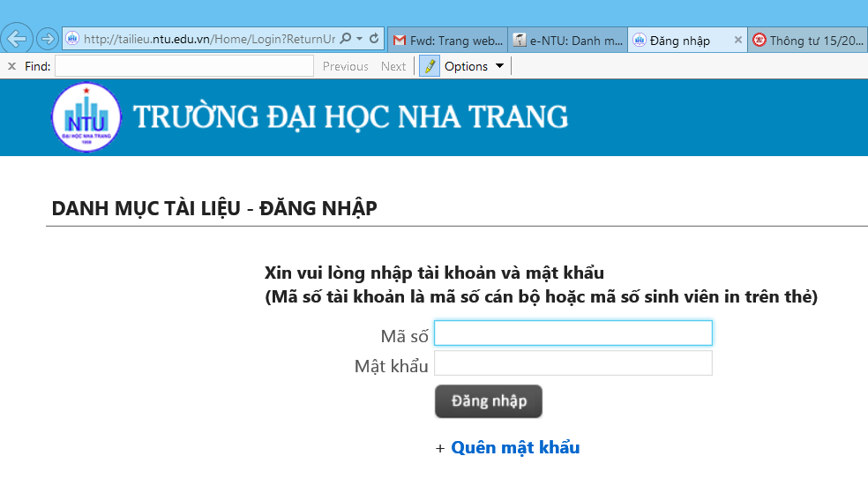
Figure 2.1
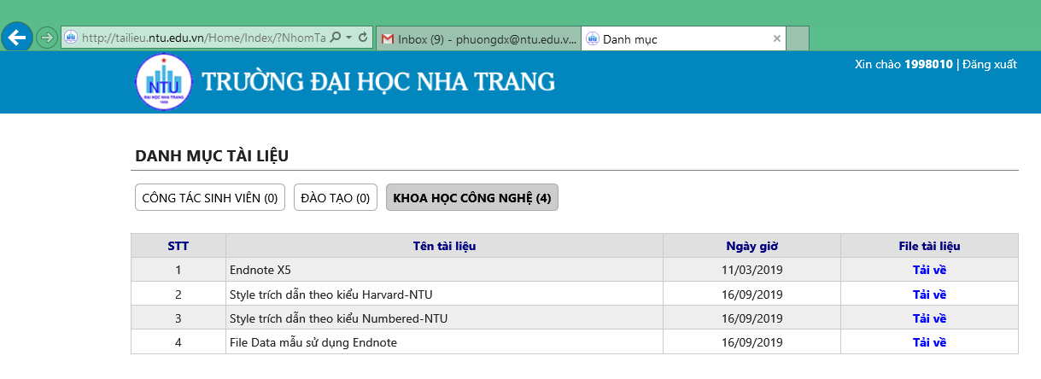
Figure 2.2

Log in with the staff number or student code as shown in Figure 2.1 (same account with the password with the training management system, student management or E-Learning system of HUST). Download the EndNote software by pressing the Download command button as shown in Figure 2.2.

- Instructions for entering data of cited documents into the software
- Go to the Reference menu > select New Reference > a window that appears as shown in Figure P2.3
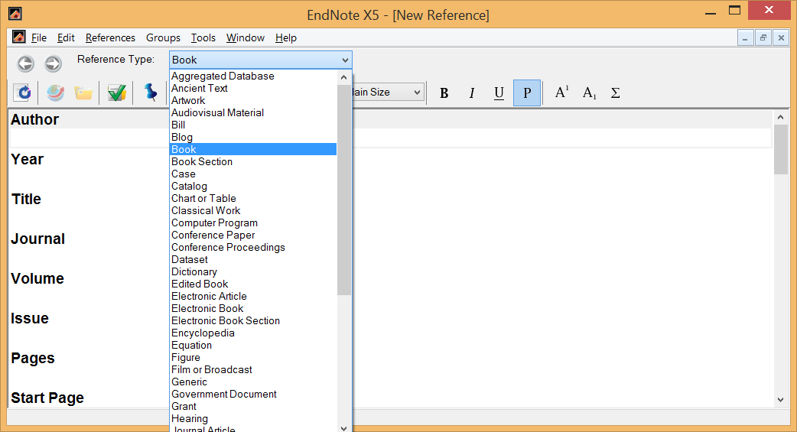
Figure P2.3
- In the Reference type section, depending on the type of reference are books (books), journals (Journal Articles), conference proceedings (Conference proceedings) ,... for which you select the corresponding document type (see Figure P2.3).
- Enter data for references/citations: there are 2 ways: (1) manual import and (2) automatic data import. Manually, you must manually enter the author name, year, title of the document, and other minimum required data fields required in the bibliography.
The first field is Author. When entering the name of the author, you need to pay attention to the format as follows:
- For foreign authors:
Enter the author's last name first, followed by a comma, followed by the author's name. The author's given name and middle name can be abbreviated initials. Each author is located in a separate row as shown in Figure P2.4 (type Enter to go down the line).
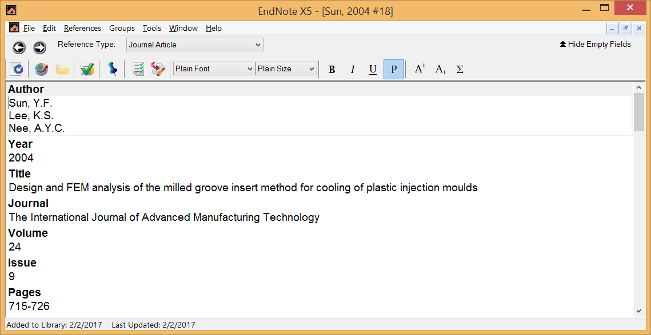
Figure P2.4
- For Vietnamese authors:
Enter your full first and last name, followed by a comma. Reason: when citing, foreign authors only write surnames but Vietnamese authors are allowed to write full names as shown. For the first author, you add the number 0 and an underscore (0_) in front (see Figure P2.5). This is the trick so that the lists of reference materials in Vietnamese will be ranked above.
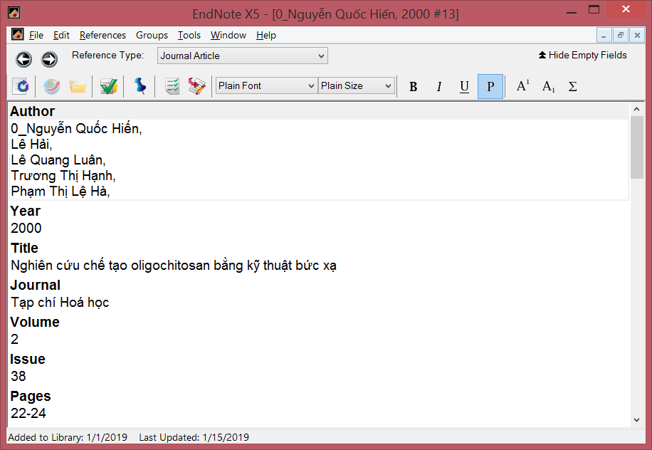
Figure P2.5
- Where references or citations are web pages:
Articles or information on websites sometimes do not have an author name or a pseudonym name. In this case, the Author field is entered with the name of the website. Due to the rules in the bibliography, websites are ranked last, so for automatic sorting, we can use the trick of adding the word "www_" in front of the name of the website – which is replaced as the name of the author (see Figure P2.6). If necessary, to give attribution to the author, you can also write the name or pseudonym of the article author (if any) in the Author information field (figure 2.7).
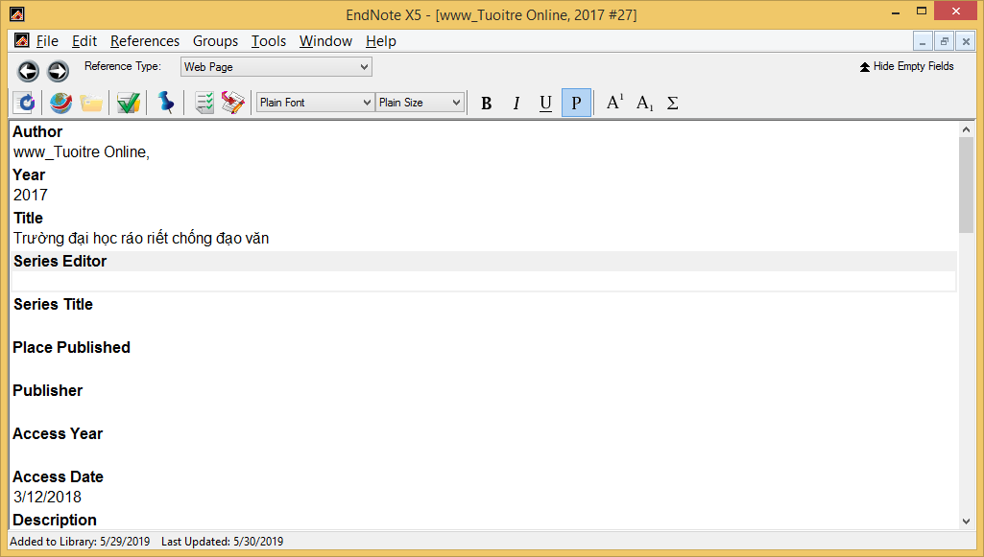
Figure P2.6
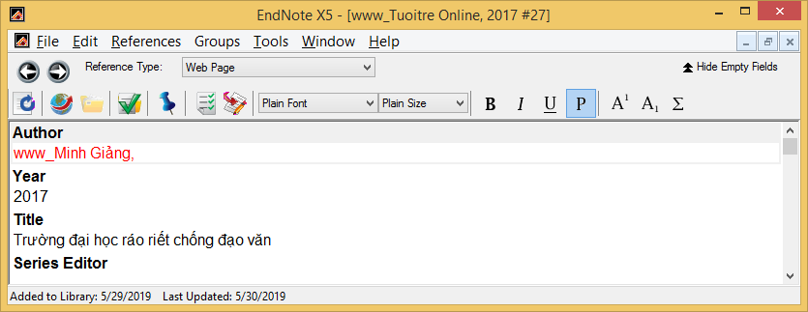
Figure 2.7
For data import, we take examples to illustrate 4 cases: using the ScienceDirect citation download utility, Springer, Taylor & Francis and Emerald insight.
- For journals on ScienceDirect:
Select the article to cite, at the top of the page there is an Export command button as shown in Figure P2.8. Click on Export citation to RIS.
Select Open > the data file will be imported into EndNote. If the data is not opened in EndNote but opened with Wordpad, you choose to Save as > save in a certain folder, then right-click on the data file with that RIS extension, select Open with EndNote.
Figure P2.8
- For magazines on Springer:
Select the article to cite, scroll that image down to the bottom right of the page with the Cite article command button as shown in Figure P2.9 => select EndNote. The citation data will be automatically imported into the EndNote software.
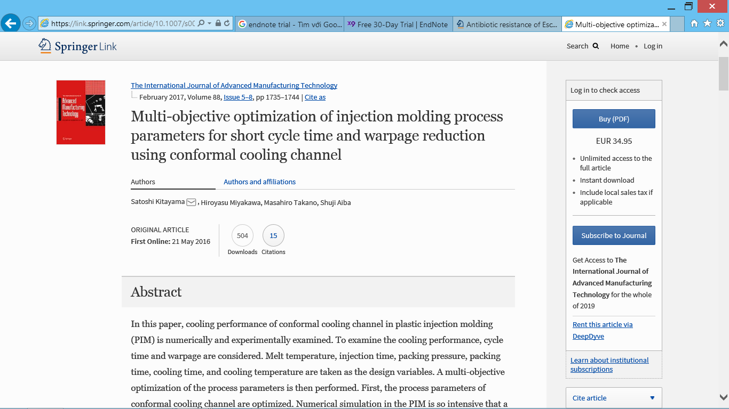
Figure P2.9
- For magazines on Taylor & Francis:
Select the article to cite, navigate to the Download citation command button as shown in Figure P2.10, then select RIS format and Download as shown in Figure P2.11
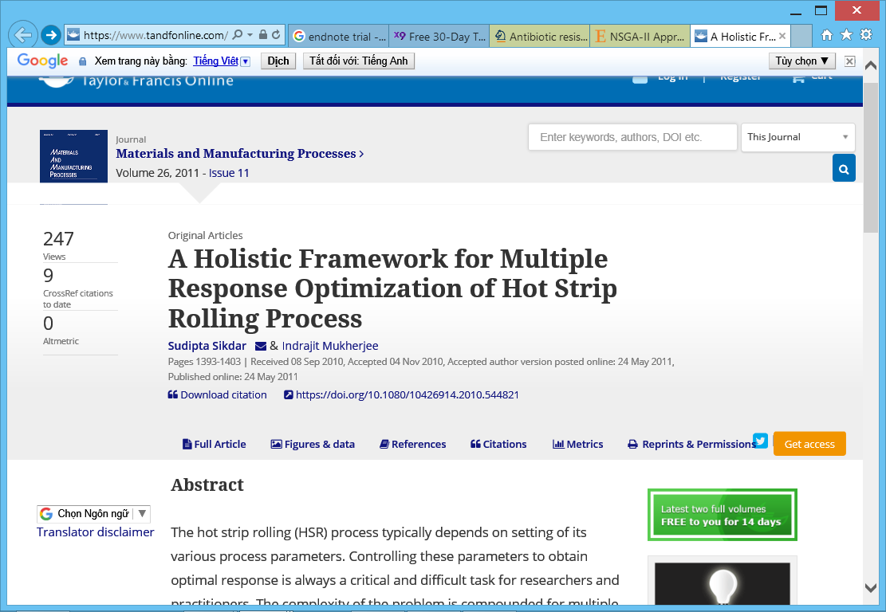
Figure P2.10
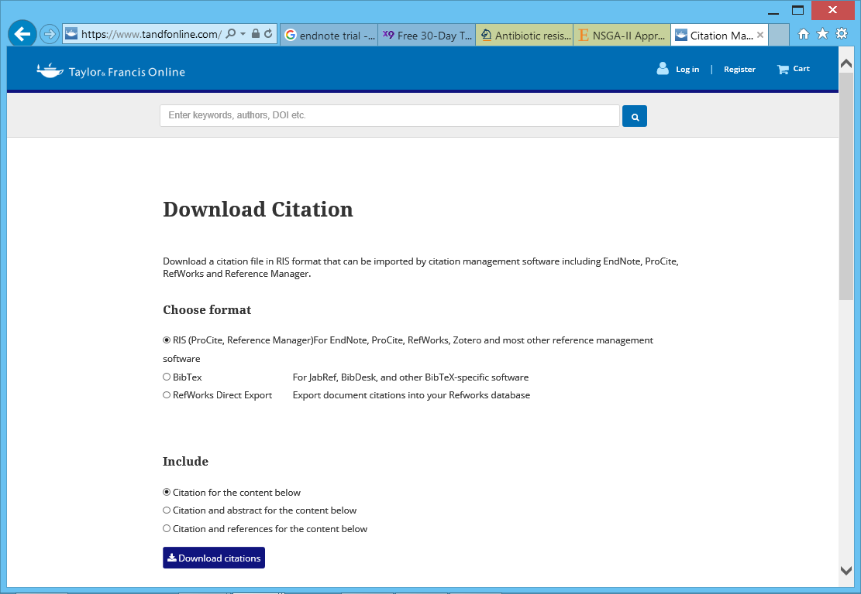
Figure P2.11
- For magazines on Emerald insight:
In the lower right corner of the page (figure P2.12), there is a Download citation command button
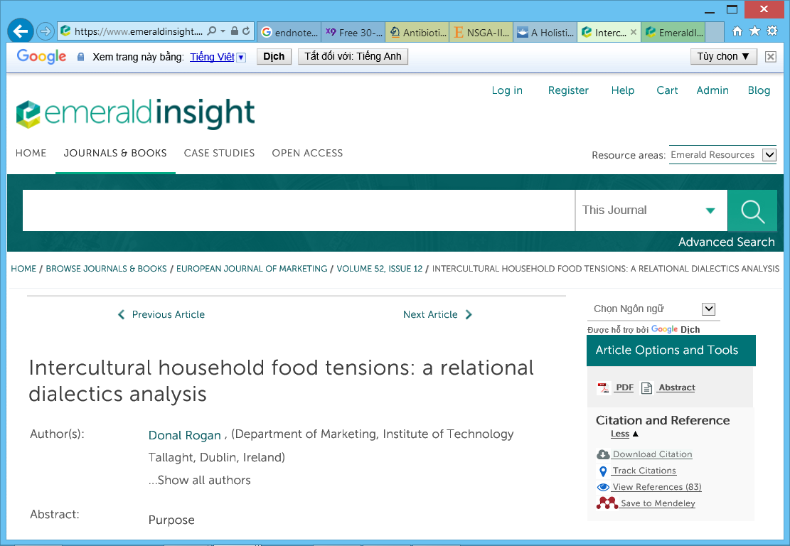
Figure P2.12
After clicking the Download citation button, select RIS format and Download article citation data as shown in Figure P2.13.

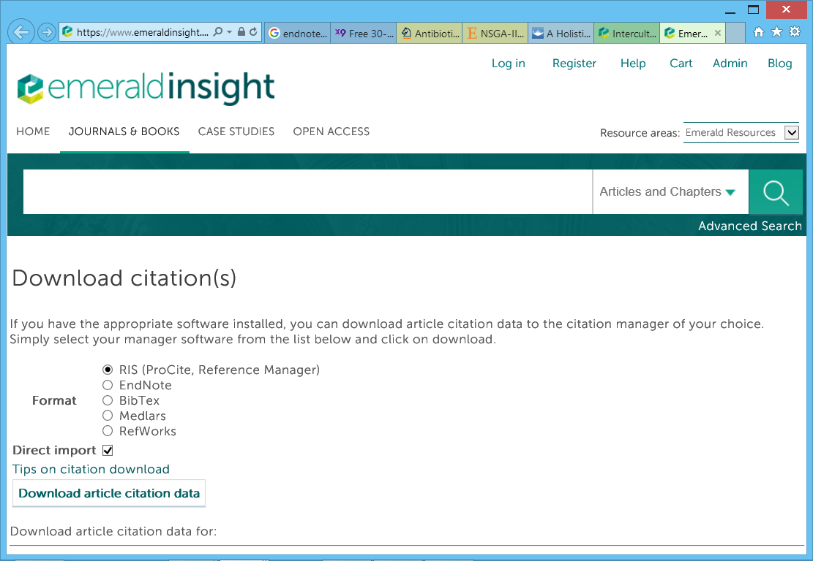
Figure P2.13

- Guide to using quote styles of Nha Trang University with Endnote
Download sample style files including Harvard-NTU.ens and/or Numbered-NTU.ens from Nha Trang University's data archive at: http://tailieu.ntu.edu.vn/ (see Figure P2.14, note the Science and Technology tab).
Figure P2.14
Download the file and save it to the EndNote installation folder (c:\Progame Files (x86)\Endnote X*\Styles (the * represents the version number of the Endnote that you have installed on your machine).
To cite in the article, perform the following steps:
- Bring the editor cursor to where the citation should be inserted.
- Open the EndNote window, select one or more citation pieces to insert, and click the Insert Citation icon as shown in Figure P2.11 (use Ctrl in combination with the mouse to select multiple citations). (Note: To make it easier for readers to practice and test, we have provided you with a sample data file (serial number 5) in Figure P2.14).
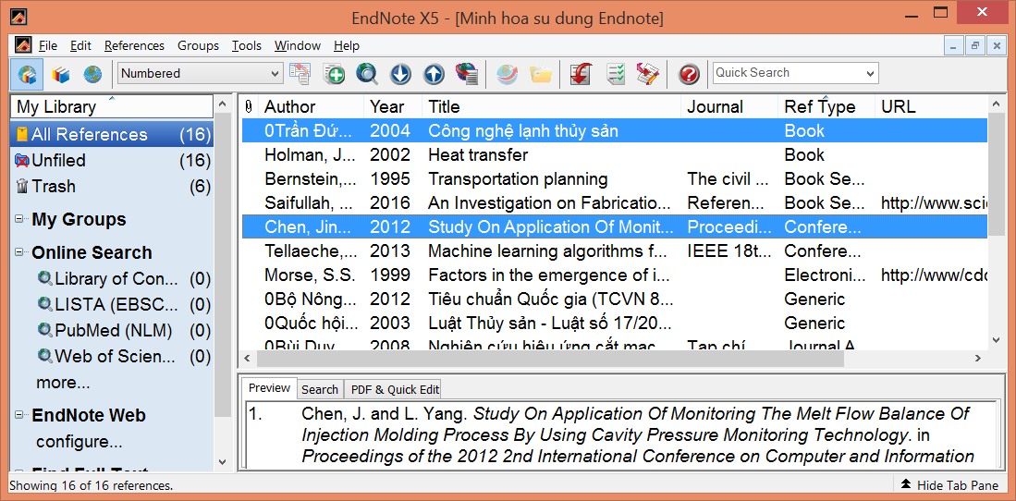
Insert a citation
TLTK bibliography and citation format format
Figure P2.15
To format the citation and TLTK bibliography in the style you want: click the Format citation format icon as shown in Figure P2.15 > a window like Figure P2.16 will appear, which allows you to select the desired citation style by clicking the Browse command button.

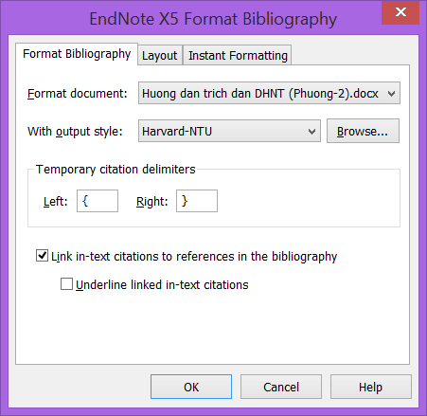
Figure P2.16

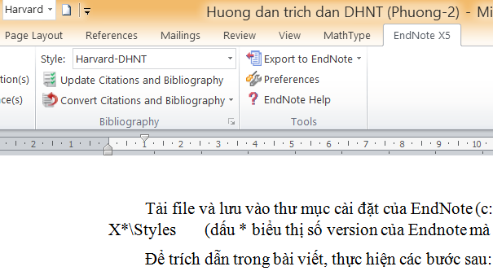

Figure P2.17

You can also select the desired citation style from the EndNote tab that is added in to the Word software as shown in Figure P2.17 when you have installed EndNote.

- Guidelines for bibliography of citations/reference materials
In the process of formatting citations as shown in Figure P2.11 (Harvard style or Numbered style), EndNote has simultaneously created for you a list of citations (references) at the end of the Word file according to the University's rules.
You just need to remove the 0_ characters immediately before the last name of the author of the documents in Vietnamese, arrange and re-align the form as Appendix 1. The word "page" in the list of Vietnamese documents is abbreviated as tr., in the list of English documents is pp., the word and in the list of English documents is written as and, so you must adjust these words in the list of documents cited to suit Vietnamese and English.
Note: To avoid the situation that after you have manually edited some of the above-mentioned places, EndNote automatically re-updates the citations and re-updates the bibliography (i.e. deletes everything that you edit in the bibliography), turn off EndNote involvement in Word:
- Go to Word Options
- Select Add-Ins, then press the Go... as shown in Figure P2.18
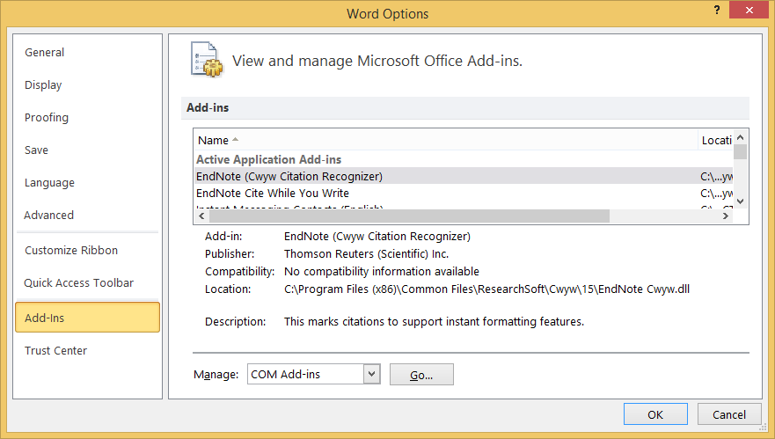
Figure P2.18
The COM Add-ins dialog box appears as shown in Figure P2.19. Select the check mark for the EndNote Cite line when you write, then press the OK button, the EndNote X5 menu will disappear on Word's menu group, which means that EndNote is no longer plugged into Word.
When you want the EndNote plug-in to Word to do citation support, do the opposite as above.

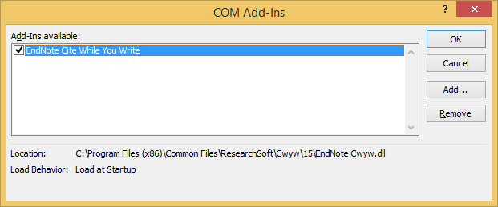
Figure P2.19

- Other important tricks in EndNote
  - Switch citations depending on how the author is quoted as the subject in the sentence or not
a) For the Harvard citation style, in case you want to change from the citation style (author, year) to author (year) for example, the following two cases:
- A valuable technique is developed... (East and West, 1972)
- East and West (1972) developed a valuable technique...
By default the citation is inserted into the post according to the format (author, year). After inserting the citation as default, to put the author's name out of the brackets in the style of the author's name (year), in the MS. Word editor, you right-click on the citation (for example East and West) > appear in the window as shown in Figure P2.120. Select Edit Citations(s) > Display as: Author (year).
Figure P2.20
To switch back from the author name style (year) back to the default style (author, year), do the same as above and select Default Format.
b) For quotations in numerical style:
For example you wrote: The circuit cutting technique was developed and introduced in the literature [3].
If you want to transfer the quotation [3] with the author's name and correct the sentence: "The circuit cutting technique was developed and introduced by Lin and Chou (2002) [3]." then right-click on the citation [3] => appear in the window as shown in Figure P2.20. Select Edit Citations(s) > Display as: Author (year) > the results will be as desired.
4.1 Insert page numbers into citations
To insert page numbers into a citation like the following example: According to Paul R. Niven (2006), KPIs are central to the BSC balanced scorecard [69, p. 30].
You right-click on the citation > select Edit Citation(s)=> appear menu as shown in P2 .21 > Choose More... > enter Suffix as p. 30 (with spaces before the letter tr.) as shown in Figure P2.22.
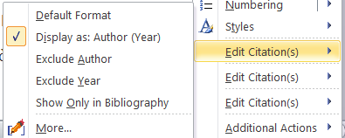
Figure P2.22
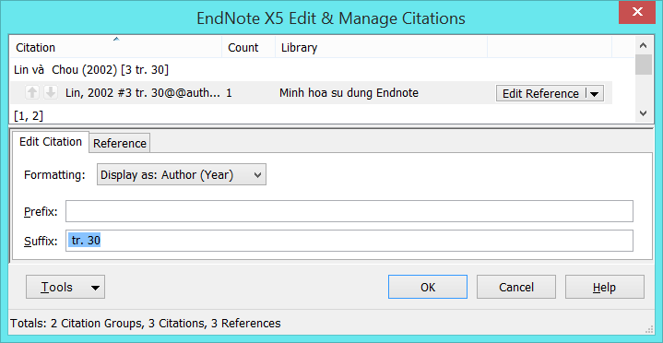
Figure P2.22

Note: Common knowledge is not needed to cite sources. Example: Water boils at a temperature of 100 ^{oC} at a pressure condition of 1 atmosphere. The climate of the Central region of Vietnam has two seasons: the sunny season and the rainy season.
Through surveying and consulting all faculties/institutes throughout the school, the field of Economics and Biotechnology & Environment often uses Harvard; the rest of the faculties/institutes usually use the Numbered type.
With or without page numbers is still OK
There are several types of abbreviations when there are more than 2 authors: dtg = co-author; CTV = Collaborator, CS = Associate.
It is only true that the bibliography cited is not required to be ranked alphabetically by the author's name/surname. According to international practice, the first cited document will be numbered [1], the documents cited later are recorded in ascending numbers. Bibliography does not rank alphabetically by author family. However, according to Vietnamese practice, separate Vietnamese documents, separate foreign languages, separate websites, so it is not possible to number the appearance of cited documents in the order in which they appear in the article.
The author's name can be placed after the quoted content.
Choose authoritative, reliable sources of information, content titles, authors or news publisher names.
Most Vietnamese schools regulate classification by name, but ranking by surname is easier to search and consistent with the way foreign language documents are classified.
Software that supports free citation: BiblioExpress, Cogitum, Papyrus, Zotero ...; software that supports paid or trial trade quotes: EndNote, ProCite, Biblioscape, RefWorks... Encourage the use of EndNote to support citations and bibliography.
Page number is abbreviated as tr. for Vietnamese scientific journals, pp. for foreign scientific journals.
To help catalog references in the prescribed format, STUDENTS, HV, NCS and GVs should use citation aids. We provide readers with standard Harvard- and Number style files to support citations, and provide a TLTK data file for the EndNote citation support tool and a Word file with citation examples and an automatically generated bibliography as shown in Appendix 1. Address to download sample reference data file: http://tailieu.ntu.edu.vn
In order to help STUDENTS, HV, NCS and teachers facilitate access, learn and use EndNote software effectively, we provide a sample data file containing common reference materials including books, scientific journals, conference proceedings, websites and generic types (generally applicable to law, standards, inventions ...). Address download sample reference data file: http://tailieu.ntu.edu.vn. The sample data file will help you a lot in getting acquainted with EndNote.

